**Rubber Hardness**

The hardness of rubber is normally expressed in Shore A. It is determined by measuring the resistance to a cone penetrator.

**Figure 1.1** — Hardness Comparison

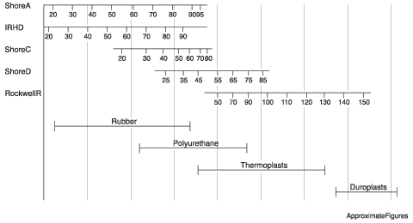

**Figure 1.2** — Hardness Correction Factor

| **Deviation in degrees of Shore A** | **Correction factor** |
| --- | --- |
| 1 | 1.038 |
| 2 | 1.087 |
| 3 | 1.118 |
| 4 | 1.161 |
| 5 | 1.205 |
| 6 | 1.251 |
| 7 | 1.298 |
| 8 | 1.348 |
| 9 | 1.399 |
| 10 | 1.458 |

# The Principle Of Anti-Vibration Mountings

Anti-vibration mountings minimise the level of vibration transmitted from an oscillatory system to its surroundings. Alternatively they can be used to protect fragile equipment from external vibrations. The amplitude of vibration of the oscillatory system itself does not decrease and must therefore be able to move with the vibration.  
  
Generally mountings should be selected to provide at least 70% isolation, i.e. no more than 30% transmission, against the lowest disturbing frequency of the system. For static applications the maximum recommended strain in the rubber is 15% in compression and 30% in shear. Certain rubber-to-metal bonded mountings can also be used in shock applications to absorb energy, and compression strain levels of up to 30% are acceptable in this type of application.

## Isolation

When there is an external force of energy maintaining the vibration of an oscillatory system, anti-vibration mountings incorporating rubber reduce the amplitude of vibration that is passed in to the surrounding structure and the system is said to have a degree of isolation.

## Damping

If the amplitude of vibration of an oscillatory system becomes progressively smaller, the system is said to be damped i.e. there is no external source of energy maintaining the amplitude of vibration and therefore the system ceases to vibrate.

Design Aspects Regarding The Mounting Of Rubber / Metal Products

### ****Figure 1.4****

|  |  |
| --- | --- |
| http://www.gmt.gb.com/images/sections/applications/img-fig1-4a.gif | http://www.gmt.gb.com/images/sections/applications/img-fig1-4b.gif |
| **Wrong:** There is metallic contact between the machine and the base. | **Right:** Machine and base are completely isolated from each other. |

### ****Figure 1.5****

|  |  |
| --- | --- |
| http://www.gmt.gb.com/images/sections/applications/img-fig1-5a.gif | http://www.gmt.gb.com/images/sections/applications/img-fig1-5b.gif |
| Placing inserts opposite one another should be avoided if possible. | **Preferred:** The thickness of the rubber is more effectively used to achieve good cushioning. |

### ****Figure 1.6****

|  |  |
| --- | --- |
| http://www.gmt.gb.com/images/sections/applications/img-fig1-6a.gif | http://www.gmt.gb.com/images/sections/applications/img-fig1-6b.gif |
| **Wrong:** The rubber is totally encapsulated and is thus unable to deform. | **Right:** The rubber is now able to deform and hence isolates the machine. |
|  |  |

Compression Loading

**Figure 1.7**

|  |  |
| --- | --- |
| http://www.gmt.gb.com/images/sections/applications/img-fig1-7a.gif | http://www.gmt.gb.com/images/sections/applications/img-fig1-7b.gif |
| http://www.gmt.gb.com/images/sections/applications/img-equ1-1.gif |  |

The shape factor must be taken into account when designing rubber mountings for compression loads. The shape factor is understood to be the ratio of the loaded area to the force free area. This is due to the restricted transverse expansion and thus the variable modulus of elasticity, E, of the incompressible rubber material.

Shear Loading

**Figure 1.8**

|  |  |
| --- | --- |
| http://www.gmt.gb.com/images/sections/applications/img-fig1-8a.gif | http://www.gmt.gb.com/images/sections/applications/img-fig1-8b.gif |
| http://www.gmt.gb.com/images/sections/applications/img-equ1-2.gif |  |

The shearing modulus G represents the only material constant of rubber and is specified for each compound in relation to Shore hardness. Therefore, the spring characteristic is linear with parallel shearing stresses. This effect must be accounted for specifically if there are shearing deformations at higher precompression.

Compression And Shear Combination Loadings

**Figure 1.9**

|  |
| --- |
| http://www.gmt.gb.com/images/sections/applications/img-fig1-9.gif |
|  |
| Anti-vibration mountings are often mounted at angles. A bridging connection between them adds stability together with a corresponding increase in the vertical deflection.  http://www.gmt.gb.com/images/sections/applications/img-equ1-3.gif |

**Tension Loading**

Where the rubber-to-metal elements are subjected to tension, peak stresses occur at the edges of the bond. If parts are oxidised, their serviceability may be destroyed due to the notch sensitivity of rubber. Therefore, tensile stresses should be avoided

Load Distribution On GMT Products

**Figure 1.10**

All mounting points should be uniformly loaded for optimum performance. For cases where asymmetric loading conditions apply, the reactions at the mounting points are determined as follows:

|  |
| --- |
| http://www.gmt.gb.com/images/sections/applications/img-fig1-10.gif |
| http://www.gmt.gb.com/images/sections/applications/img-equ1-4.gif |

# Relationship Between Vibration Transmission, Disturbing Frequency And Deflection

### ****Figure 1.11****

|  |
| --- |
| http://www.gmt.gb.com/images/sections/applications/img-fig1-11.gif |

Example 1 — Mounting Method And Part Selection

It is important that anti-vibration mountings are loaded in the correct manner in order to provide the required isolation. This is illustrated in the following typical example (fig 1.12) in which a motor, bellhousing and pump, each of known mass, require isolation. The overall centre of gravity must first be located for the set-up shown.

### ****Figure 1.12****

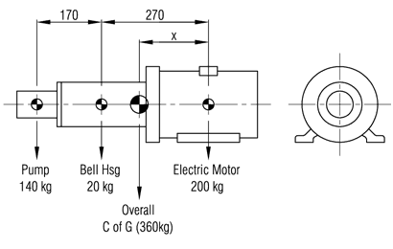

In order to find the overall centre of gravity of the set-up, which is required to determine mounting positions, it is necessary to take moments.

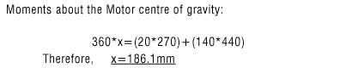

### ****Figure 1.13****

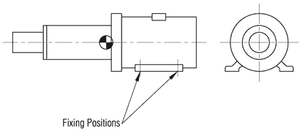

The standard motor fixing positions are shown in figure 1.13. It may initially be considered that GMT anti-vibration mountings can be located in these positions. However, this is unsuitable in this case as it can be seen that the overall centre of gravity acts to the left of these fixing positions and so anti-vibration mountings would be unevenly loaded and more seriously, the outermost mountings would be subject to tension which is not recommended. Therefore, it is necessary to rigidly support (i.e. bolt solid to solid) the set-up to a subframe which will then provide positions for the anti-vibration mountings to be installed as shown in figure 1.14.

### ****Figure 1.14****

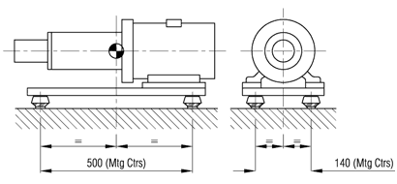

In this way, equal loading of the mountings is achieved whilst ensuring they are subjected to only compressive forces. It is now necessary to select suitable mountings to adequately isolate the machine as follows:-  
  
For this example, the running speed of the motor is 1450rpm. (NOTE : Had there been equipment with differing running speeds then the lower running speed would be used in the calculations.)

img-equ1-6

With reference to the graphical illustration of the relationship between vibration transmission, disturbing frequency and deflection (figure 1.11), a static deflection of approximately 1.8mm is required to give 70% isolation at a running speed of 1450 rpm. A suitable mounting to obtain this desired deflection for the calculated load is a GMT Machine Foot Part No.M/C-MF1890 in 50° Shore A rubber hardness. (An alternative to this part is a GMT Buffer Type A 50/30 in 57° Shore A rubber hardness which gives a deflection of approximately 2.2mm under a load of 90kg which will increase the isolation to 76%.)

Example 2 — Shock Protection, e.g.: A Mass Driven Down By A Force, Striking A Rubber Buffer

It is often necessary to reduce the shock/impact of objects coming to rest and in such applications a rubber element is used as a spring to absorb the energy of the moving object. A typical example is illustrated as follows: A mass of 200kg, initially at rest in position 1 (refer to figure 1.15), is driven down by a force of 0.25kN and by the force of gravity through a distance of 0.22 metres. By the conservation of energy principle:

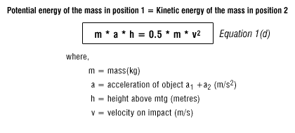

### ****Figure 1.15****

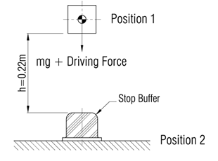

The acceleration of the mass due to the 0.25kN force is calculated from:

img-equ1-8

The acceleration of the mass due to the gravitational force is:

img-equ1-9

Substituting in equation 1(d):

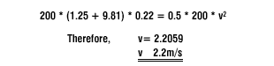

The formula for calculating the required energy absorption is:

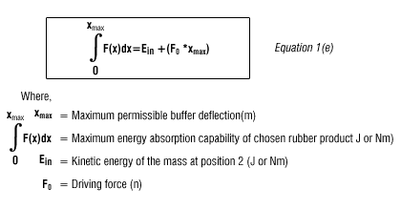

A GMT Stop Buffer would provide suitable impact protection due to its ability to absorb high shock loads. By a series of linear approximations to the curve at intervals of dx metres deflection, the total area under the graph can be obtained and hence the maximum permissible energy by the buffer can be evaluated (Refer to figure 1.16)

### ****Figure 1.16****

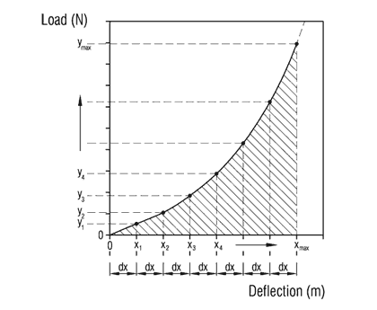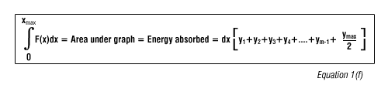

We find that, applying equation1(e) to a GMT Stop Buffer Type RB1073 in 71° Shore A rubber hardness with a value for Xmax taken to be 0.04m (i.e. 50% compression strain - this percentage being dependant upon how frequently the mounting is subjected to the shock loading):

img-equ1-13

And applying equation 1(f):

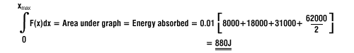

Therefore, the selected GMT Stop Buffer Type RB1073 in 71° Shore A can absorb the 494J of energy, as it has the capacity to absorb 880J at 50% strain. Alternatively if space is a problem, parts of smaller size and capacity can be selected and mounted in sets of 2, 3, 4 etc.